PORTOS Project

Application for the Testing of Marine Renewable Energy Devices and Technologies

Second Call September 2020

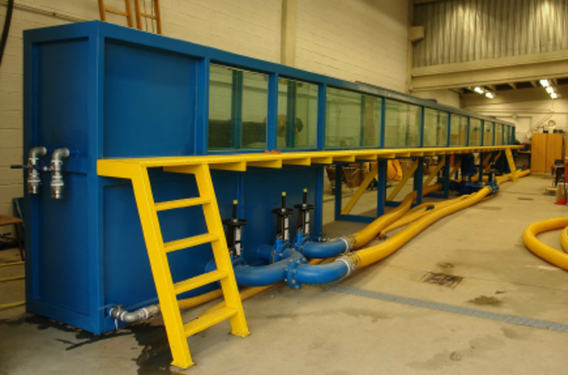

Wave flume at the Universida de de Santiago de Compostela

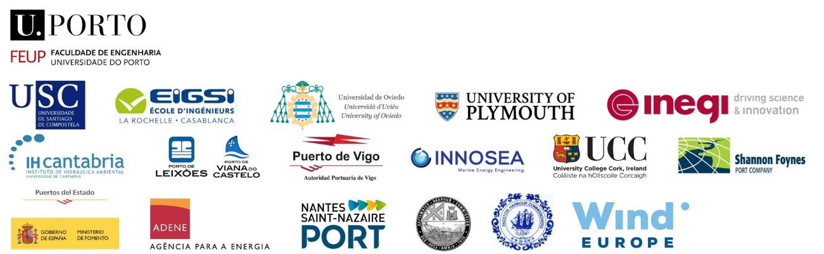

Project Details
Project acronym | PORTOS
Project title | Ports Towards Self-Sufficiency

Completed application forms should be returned to nathan.kirwan@ucc.ie with all necessary documentation before 16.10.20

Introduction
Sea ports have high-energy requirements which are normally catered for by fossil fuels and are a source of air pollution, two environmental problems that can be minimised by using renewable energy. Considering the convergence of resources, infrastructures and facilities in ports, marine renewable energy (MRE) has the potential to be a promising alternative.
PORTOS aims to assess, develop and promote the integrated use of renewable energy resources in Atlantic Area ports and increase their energy efficiency, establishing a roadmap to a more competitive and sustainable sector. Although there are proven technologies to harness MRE, new concepts are continuously being invented by academic, non-academic and industry inventors and entrepreneurs, who may not have enough resources and expertise to develop their ideas further.

In that regard applicants are invited to submit an application for the testing of their MRE device or technology to an independent Selection Panel (SP) comprising of experts in this sector. The SP positively appreciates solutions that can be integrated into ports.
Successful applicants will have access to one of the following facilities for two weeks;
- Universidade de Santiago de Compostela – USC (ES) wave/current flume;
- Ecole d’Ingenieurs en Genie des Systemes Industriels – EIGSI (FR) technical assessment of novel technologies;
- Universidad de Oviedo – UNIOVI (ES) – numerical modelling of novel technologies.
The institutions have various facilities. The maximum access that will be granted is two weeks. The researchers at each facility have vast experience and knowledge on MRE which will prove invaluable during the test. Applicants are required to contact the test facility prior to applying to ensure they can facilitate the campaign. All fields below should be completed for the best chance of success. Please read the Application Guidelines before applying.

Group Details
Project Leader details (enclose a curriculum vitae also)
Title
Family name
First name
Gender
Birth year
Nationality
Country where appl. Works
Phone
Email
Company name
Company acronym
Position in Company
Company postal address
Company country
Company web address
Please also include details for all other members of the group (if any) as above.

Project Member details, if applicable (enclose a curriculum vitae also)
Title
Family name
First name
Gender
Birth year
Nationality
Country where appl. Works
Phone number
Email
Company name
Company acronym
Position in Company
Company postal address
Company country
Company web address
Please include details for all other members of the group (if any) as above.
Access Details
Research infrastructure for which you are applying for access;
Is this your only PORTOS application in this call? |  | Yes / No
If No, please give details: (approx. 100 words)

Length of time required for testing (maximum of two weeks)
Suggested start date
Details of any major timing constraints when you will be unable to test within the testing period (March 2020 – March 2021) (100 words approx.)

History
Selection and eligibility
New user: have you ever used (for research purposes) the proposed Research Infrastructure before? | Yes / No
If Yes, please give details: (approx. 100 words)

Description
Brief summary of the proposed work (approx. 100 words)
Do you have a model already fabricated or have you the capacity to do so? Give details (approx. 100 words)
Please attach up to two images of the device being submitted for testing. Images must be in JPEG or PNG format only. Videos of model outlining the working principle can also be submitted.

Introduction - include background, scientific/technical context of the tests (if previously tested, please give brief details of the most recent test location/facility, dates and result achieved in relation to design requirements). (approx. 300 words)

Patent of technology – patent status, is the technology patented? (approx. 100 words)

Project objectives - including potential commercial benefits/progress. (approx. 100 words) Please see Application Guideline for Intellectual Property arrangement.

Potential impacts of proposed testing (scientific, commercial, environmental) (approx. 100 words)

Outline test plan and timeline (approx. 300 words) - include proposed plan of work and timing. It is important that the scope of work be very well focused with clearly defined primary and secondary objectives. Include full timings (for setup, calibration, testing, removal etc.) Please contact the facility you hope to test at before commencing with this section. Contact details are in the Application Guidelines.

Specific requirements (approx. 300 words) - include details of tentative equipment/instrumentation/materials required (subject to what is offered by the infrastructure - see infrastructure description), technical assistance and training required etc.:
Analysis (approx. 100 words) - Please briefly outline your plans for the proposed analysis of the results following access.

If previous tests have been carried out, please include the summary description of the most recent results here: (approx. 300 words)

Prior discussion with Research Infrastructure manager/contact
It is mandatory for applicants to contact the Facility Manager prior to proposal submission for preliminary discussions to establish feasibility of the project for the facility, equipment availability and timing. Please give brief detail of your discussion with the Facility Manager and their conclusion with regard to the feasibility of your project for the facility. (approx. 300 words)

